


This certificate is presented to:
PARTICIPANT NAME
In recognition of your attendance and completion of the Microsoft Student Ambassadors workshop on
EVENT NAME

Workshop on EVENT DATE, organized by the Microsoft Student Ambassador.
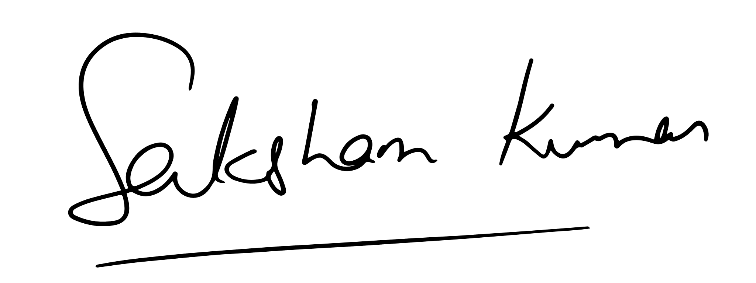
HOST NAME
Microsoft Learn Student Ambassador (Gold)

